Heptagrammic Cupola
# Source: AI Source: Provided by: [Data Path: Persons Table -> ID Column: 1, Name_En Column: Motasem Essam] -> From: [ChatGPT] on [7/25/2026
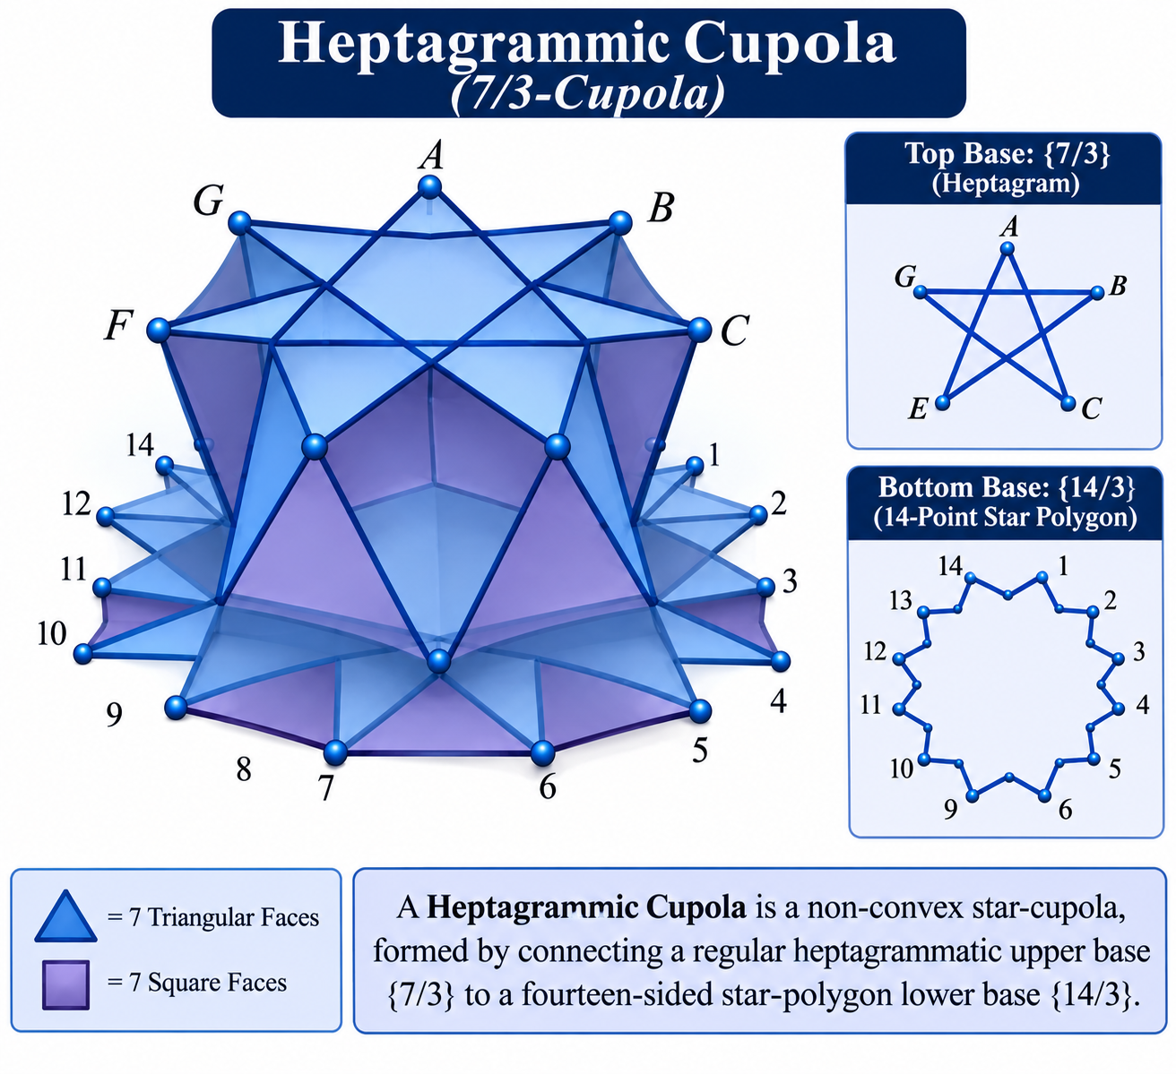

Definition
# Source: AI Source: Provided by: [Data Path: Persons Table -> ID Column: 1, Name_En Column: Motasem Essam] -> From: [ChatGPT] on [7/25/2026]
A Heptagrammic Cupola, also known as a 7/3-Cupola, is a non-convex star-cupola formed by connecting a regular heptagrammatic upper base $\{7/3\}$ to a fourteen-sided star-polygon lower base $\{14/3\}$.
Its lateral structure consists of seven triangular faces and seven square faces arranged around the two star-polygon bases. <Cite refs={["turn509746search11","turn509746search3"]}/>
]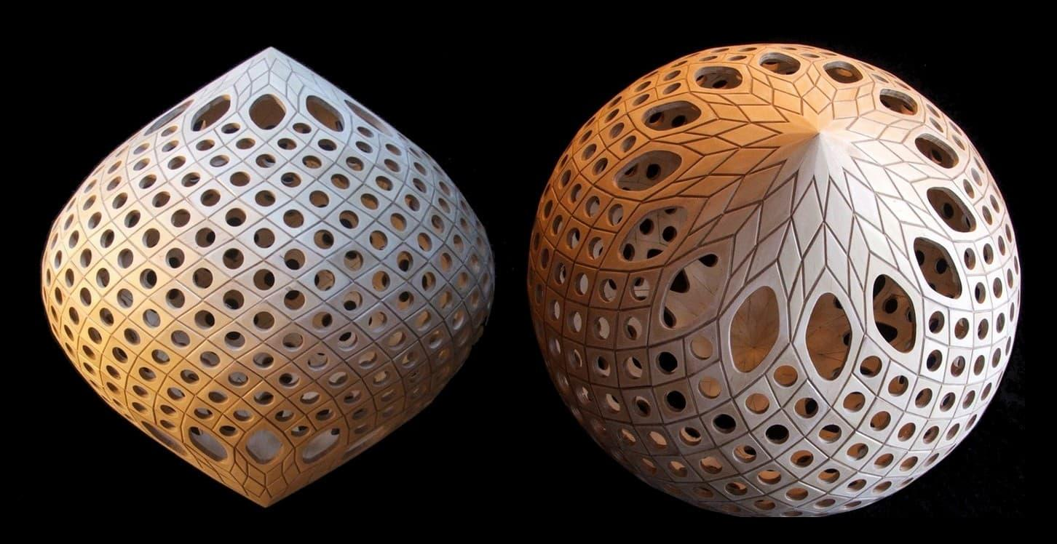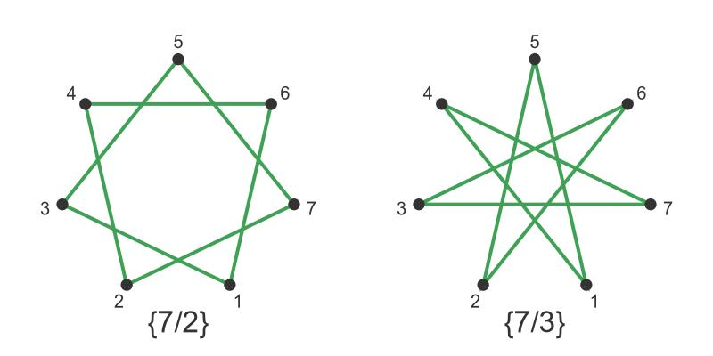

Geometric Structure
# Source: AI Source: Provided by: [Data Path: Persons Table -> ID Column: 1, Name_En Column: Motasem Essam] -> From: [ChatGPT] on [7/25/2026]
The Heptagrammic Cupola consists of:
- Upper Base: A regular heptagram represented by the star-polygon notation $\{7/3\}$.
- Lower Base: A fourteen-sided star polygon represented by $\{14/3\}$.
- Triangular Faces: Seven triangular lateral faces.
- Square Faces: Seven lateral square faces.
- Star Arrangement: The lateral faces connect the two bases according to the heptagram's vertex sequence.
<Cite refs={["turn509746search11","turn509746search3"]}/>

Face Composition
# Source: AI Source: Provided by: [Data Path: Persons Table -> ID Column: 1, Name_En Column: Motasem Essam] -> From: [ChatGPT] on [7/25/2026]
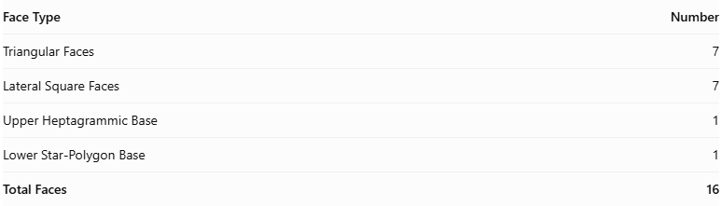
Face Type | Number
Triangular Faces | 7
Lateral Square Faces | 7
Upper Heptagrammic Base | 1
Lower Star-Polygon Base | 1
Total Faces | 16
The two bases are star polygons, while the fourteen lateral faces form the cupola's connecting structure.

Mathematical Properties
# Source: AI Source: Provided by: [Data Path: Persons Table -> ID Column: 1, Name_En Column: Motasem Essam] -> From: [ChatGPT] on [7/25/2026]

Property | Value
Total Faces (F) | 16
Total Edges (E) | 35
Total Vertices (V) | 21
Upper Base | $$\{7/3\}$$
Lower Base | $$\{14/3\}$$
Rotational Symmetry | Order 7
Geometric Type | Non-convex star polyhedron
Cupola Notation | $$7/3-Cupola$$
The face, edge, and vertex counts follow the general cupola formulas:
$$F=2n+2, E=5n, V=3n$$
For $n=7$:
$$F=16, E=35, V=21$$
Euler's Polyhedron Formula:
$$V-E+F=21-35+16=2$$
<Cite refs={["turn509746search2","turn509746search3"]}/>

Geometric Characteristics
# Source: AI Source: Provided by: [Data Path: Persons Table -> ID Column: 1, Name_En Column: Motasem Essam] -> From: [ChatGPT] on [7/25/2026]
- Non-Convex Structure: Its star-polygon bases create a non-convex geometric arrangement.
- Heptagrammic Upper Base: The upper base follows the $\{7/3\}$ vertex sequence.
- Fourteen-Sided Star Base: The lower base follows the $\{14/3\}$ sequence.
- Sevenfold Rotational Symmetry: Its structure repeats after a rotation of approximately ${51.43}^{∘}$.
- Cupola Construction: It has seven triangular and seven square lateral faces.
- Star-Polygon Connection: It belongs to the family of star-cupolae rather than ordinary convex cupolae.

Constructing Heptagrammic Cupola in Solid Geometry

Geometric Instruments Used
# Source: AI Source: Provided by: [Data Path: Persons Table -> ID Column: 1, Name_En Column: Motasem Essam] -> From: [ChatGPT] on [7/25/2026]
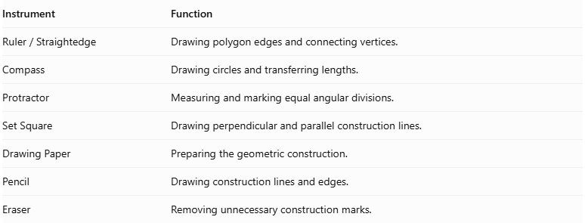
Instrument | Function
$$Ruler/Straightedge$$ | Drawing polygon edges and connecting vertices.
Compass | Drawing circles and transferring lengths.
Protractor | Measuring and marking equal angular divisions.
Set Square | Drawing perpendicular and parallel construction lines.
Drawing Paper | Preparing the geometric construction.
Pencil | Drawing construction lines and edges.
Eraser | Removing unnecessary construction marks.

Instrument-Based Construction Procedures

Constructing the Lower Tetradecagrammic Base
# Source: AI Source: Provided by: [Data Path: Persons Table -> ID Column: 1, Name_En Column: Motasem Essam] -> From: [ChatGPT] on [7/25/2026]
- Draw a circle using a compass.
- Mark its center.
- Divide the circumference into fourteen equal angular sections.
- Each central angle measures:
$$\frac{{360}^{°}}{14}≈{25.7143}^{°}$$
- Mark the fourteen equally spaced points around the circle.
- Starting from one point, connect every third point in sequence.
- Continue until the sequence returns to the starting point.
- Complete the tetradecagram $\{14/3\}$.
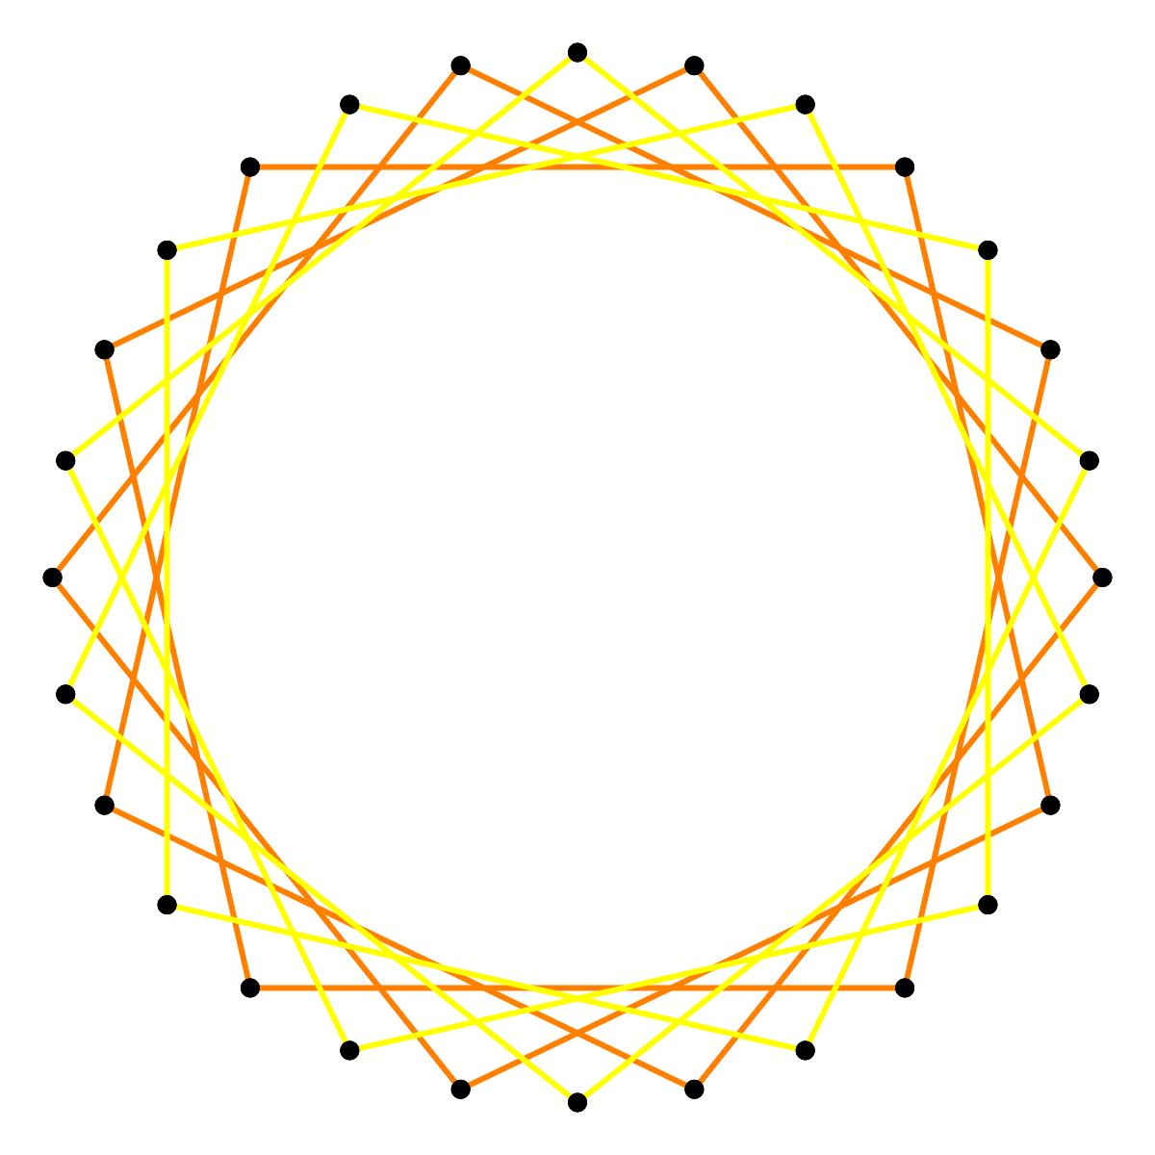

Constructing the Upper Heptagrammic Base
# Source: AI Source: Provided by: [Data Path: Persons Table -> ID Column: 1, Name_En Column: Motasem Essam] -> From: [ChatGPT] on [7/25/2026]
- Draw a second circle using a compass.
- Divide the circumference into seven equal angular sections.
- Each central angle measures:
$$\frac{{360}^{°}}{7}≈{51.4286}^{°}$$
- Mark the seven equally spaced points.
- Starting from one point, connect every third vertex in sequence.
- Continue until the sequence returns to the starting point.
- Complete the heptagram $\{7/3\}$.

Positioning the Two Bases
# Source: AI Source: Provided by: [Data Path: Persons Table -> ID Column: 1, Name_En Column: Motasem Essam] -> From: [ChatGPT] on [7/25/2026]
- Draw the lower tetradecagram in the lower position.
- Draw the upper heptagram above it.
- Keep the intended base planes parallel.
- Align the two star polygons according to the heptagrammic cupola arrangement.
- Maintain seven-fold rotational symmetry.
- Preserve the star-polygon orientation rather than using the ordinary heptagonal cupola arrangement.

Constructing the Seven Lateral Square Faces
# Source: AI Source: Provided by: [Data Path: Persons Table -> ID Column: 1, Name_En Column: Motasem Essam] -> From: [ChatGPT] on [7/25/2026]
- Identify the seven square-face positions around the structure.
- Connect the appropriate edges of the lower tetradecagram to the upper heptagram.
- Construct the seven lateral square faces according to the star-cupola arrangement.
- Connect their corresponding vertices.
- Check the intersections and connections with the neighboring triangular faces.

Constructing the Seven Triangular Faces
# Source: AI Source: Provided by: [Data Path: Persons Table -> ID Column: 1, Name_En Column: Motasem Essam] -> From: [ChatGPT] on [7/25/2026]
- Identify the seven positions between the lateral square faces.
- Connect the appropriate remaining vertices of the upper and lower bases.
- Construct seven triangular lateral faces.
- Ensure that each triangle completes the intended alternating arrangement.
- Preserve the star-shaped intersections of the structure.

Completing the Three-Dimensional Representation
# Source: AI Source: Provided by: [Data Path: Persons Table -> ID Column: 1, Name_En Column: Motasem Essam] -> From: [ChatGPT] on [7/25/2026]
- Review all sixteen faces.
- Check the connections between both star-polygon bases and the lateral faces.
- Distinguish visible edges from hidden edges.
- Use different line styles to indicate intersecting or obscured edges.
- Add shading to distinguish the triangular and square faces.
- Verify that the result represents a Heptagrammic Cupola rather than a Crossed Heptagrammic Cupola.
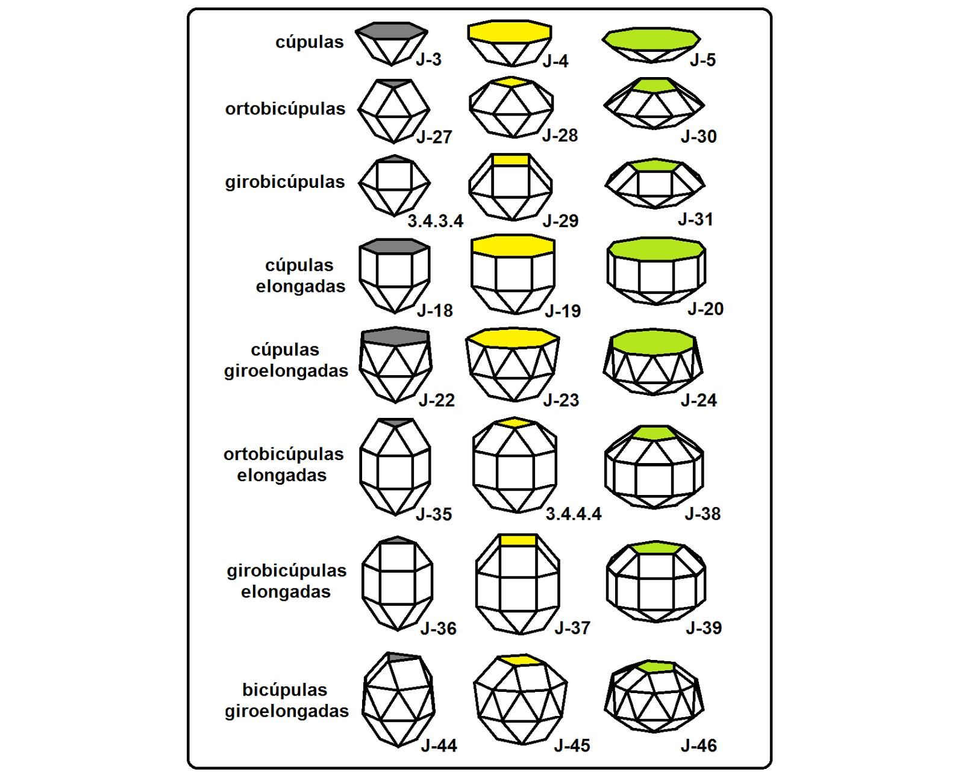
Construction note: A regular heptagon cannot be constructed exactly using only an unmarked straightedge and compass. A protractor can be used to mark the required angular divisions for an instrument-based drawing. The same limitation applies to the regular tetradecagon.

Key Points
# Source: AI Source: Provided by: [Data Path: Persons Table -> ID Column: 1, Name_En Column: Motasem Essam] -> From: [ChatGPT] on [7/25/2026]
- Alternative Name: 7/3-Cupola.
- Upper Base: Heptagram $\{7/3\}$.
- Lower Base: Star Polygon $\{14/3\}$.
- Lateral Faces: 7 Triangles and 7 Squares.
- Total Faces: 16.
- Total Edges: 35.
- Total Vertices: 21.
- Rotational Symmetry: Order 7.
- Classification: Non-convex Star-Cupola.

Main Classification
# Source: AI Source: Provided by: [Data Path: Persons Table -> ID Column: 1, Name_En Column: Motasem Essam] -> From: [ChatGPT] on [7/25/2026]
Solid Geometry
└── Types of Solids
└── Star-Cupola
└── Types of Star-Cupola
└── Heptagrammic Cupola

Conclusion
# Source: AI Source: Provided by: [Data Path: Persons Table -> ID Column: 1, Name_En Column: Motasem Essam] -> From: [ChatGPT] on [7/25/2026]
The Heptagrammic Cupola is a non-convex star-cupola characterized by its heptagrammic upper base, fourteen-sided star-polygon lower base, and alternating triangular and square lateral faces. It has 16 faces, 35 edges, and 21 vertices, with sevenfold rotational symmetry.

